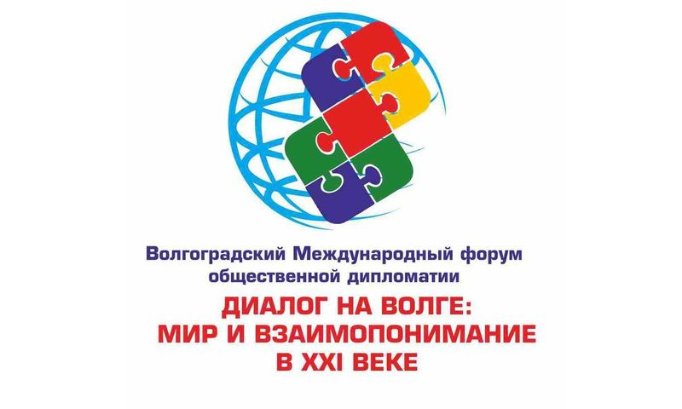

RESOLUTION
of the International Forum of People’s Diplomacy
“Dialogue on the Volga: Peace and Mutual Understanding in the 21st century”

We, the undersigned participants of the International Forum of People’s Diplomacy “Dialogue on the Volga: Peace and Mutual Understanding in the 21st century”, which took place in Volgograd (Russia) on October 31– November 1, 2016 on the occasion of the World Cities Day designated by the UN General Assembly for annual celebration,
- acknowledging the merits of the cities of Coventry (Great Britain) and Stalingrad-Volgograd (Russia), which in 1944 laid the foundations for the international twinning movement,
- taking into account the many years of Stalingrad-Volgograd’s (Russia) experience in the development and promotion of the ideas of peace and people’s diplomacy,
- developing friendly relations between nations on the basis of the principles of respect, equal rights and self-determination of peoples,
- vigorously condemning all manifestations of violence, discrimination, xenophobia, racism, attempts to rehabilitate fascism and reconsider the historic outcome of World War 2,
- supporting the ideas of disarmament, peaceful coexistence, consolidation of the international community for the sake of peace and security on the planet,
- acknowledging that the global character of the changes taking place in today’s world has a menacing character and calls for an immediate search of constructive ways of overcoming political, economic, social and humanitarian problems,
- recognizing the growing role of people’s diplomacy in overcoming another outburst of international confrontation and in cementing relations between peoples,

have resolved:

- To support the initiative of the civic society and the government of Volgograd region to establish in the territory of the hero-city of Volgograd (Russia) a standing international discussion platform on the acute security problems and on the development of conceptual ways of improving the world order;
- Put into practice the annual holding of the International Forum of People’s Diplomacy in Volgograd (Russia) on October 31 – on the World Cities Day – encouraging the participation of the representatives of governments, parliaments, municipalities, international organizations and unions, members of academic communities, experts and people’s diplomacy activists;
- Hold the next meeting of the International Forum of People’s Diplomacy in Volgograd on October 31, 2017 on the topic: “Strategy and ideology of peace in the 21st century”;
- Address European structures working in the area of people’s diplomacy with an appeal to support initiatives aimed at the building of the “Big Eurasia” as a community of security and emphasizing the impermissibility of the expansion of military infrastructure in Europe;
- Be more active in encouraging the participation of youth, civic society representatives, media representatives from various countries in the Forum to exchange and spread objective information about the international agenda;
- Contribute to the dissemination of the information about the work of the International Forum of People’s Diplomacy in Volgograd via various media, as well as of the information about the positive peace building experience of the cities and countries participating in the Forum;
- Entrust the Forum’s organizing committee with sending this resolution to the municipalities and people’s diplomacy structures from the twin and partner-cities of Volgograd, international organizations and unions.

Participants of the Forum are convinced:
The implementation of the suggestions listed in this Resolution will contribute to the strengthening of peace and security, the development of international links in accordance with the principles and norms of the international law, the development of municipal institutions in the areas of politics, economics, culture, humanitarian sphere, and serve the interests of the civic society.
The resolution is composed in the Russian and English languages, each of them being equally deeming and binding.
Volgograd November 1, 2016

__________________________________________________________________
__________________________________________________________________
__________________________________________________________________
__________________________________________________________________
__________________________________________________________________
__________________________________________________________________
__________________________________________________________________
__________________________________________________________________
__________________________________________________________________
__________________________________________________________________
__________________________________________________________________
__________________________________________________________________
__________________________________________________________________
__________________________________________________________________
__________________________________________________________________
__________________________________________________________________
__________________________________________________________________
__________________________________________________________________
__________________________________________________________________

